3-1、RGB WS2812B

1. 参考《0-1》文档，插入ESP32模块。
2. 用导线连接IO口与RGB控制口，如下图所示：

红色线<------->RGB

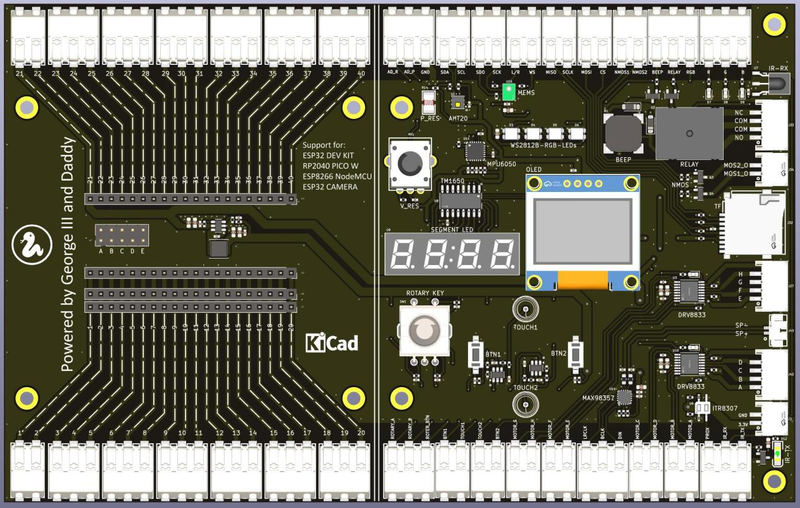

1. 代码示例

#main.py

from machine import RTC,Pin,Timer

import time

import neopixel

from neopixel import NeoPixel

# create output pin

data_WS2812 = 32

# number of RGBs

num_WS2812 = 4

pin = Pin(data_WS2812,Pin.OUT)

np=neopixel.NeoPixel(pin,n=4,bpp=3)

def Light_clear():

for i in range(0,num_WS2812):

np[i]=(0,0,0)

np.write()

def do_rgb():

Light_clear()

while True:

for i in range(num_WS2812):

time.sleep_ms(10)

np[i]=(255,0,0)

np.write()

time.sleep_ms(200)

Light_clear()

for i in range(num_WS2812):

np[i]=(0,255,0)

np.write()

time.sleep_ms(200)

Light_clear()

for i in range(num_WS2812):

np[i]=(0,0,255)

np.write()

time.sleep_ms(200)

Light_clear()

while True:

do_rgb()

1. 上传main.py到模块中，按F5或点击运行按钮，就可以看见下图所示的4个LED的显示效果。

